DIABETES PREDICTION USING DATA ANALYTICS

A Healthcare Predictive Analytics Project

Prepared by:

Sharifa Mohammad
B-Tech in Artificial Intelligence & Data Science(AI&DS)
Sir C R Reddy College of Engineering, Andhra Pradesh,Eluru

Date: 20 May 2026

1

1. Introduction
This project applies data analytics techniques to predict the risk of diabetes using patient medical records. The dataset used is the Pima Indians Diabetes dataset from the UCI Machine Learning Repository. The objective is to explore the dataset, identify meaningful patterns, and apply predictive models to generate insights into diabetes risk factors.

2. Workflow Overview
The project follows a structured data analytics pipeline:

- Data Collection – Import dataset into Python environment.
- Data Preprocessing – Handle missing values, replace invalid entries, normalize features.
- Exploratory Data Analysis (EDA) – Use statistical summaries and visualizations to understand distributions and correlations.
- Feature Engineering – Identify and refine variables that influence diabetes risk.
- Modeling – Apply classification algorithms (Random Forest, Logistic Regression, XGBoost)
- Evaluation – Assess model performance using accuracy, precision, recall, F1-score, and ROC-AUC.
- Insights & Reporting – Highlight key predictors and ethical considerations.
2
Flowchart 3
Start
↓
Load Dataset
↓
Preprocess Data
↓
Exploratory Data Analysis (EDA)
↓
Train/Test Split
↓
Model Training
↓
Model Evaluation
↓
Feature Importance
↓
Results & Insights
↓
End

3. Data Preprocessing
- Columns with invalid zero values (Glucose, BloodPressure, SkinThickness, Insulin, BMI) were corrected using median imputation.
- Features were standardized using StandardScaler to ensure consistency.
- Dataset was split into training (80%) and testing (20%) subsets
4. Exploratory Data Analysis (EDA)
EDA was performed to uncover patterns and relationships:
- Class Distribution: Balanced view of diabetic vs non-diabetic patients.
- Histograms: Showed feature distributions (Glucose, BMI, Age).
- Correlation Heatmap: Revealed strong correlation between Glucose and Outcome.
- Boxplots: Identified outliers in BMI and Insulin values.
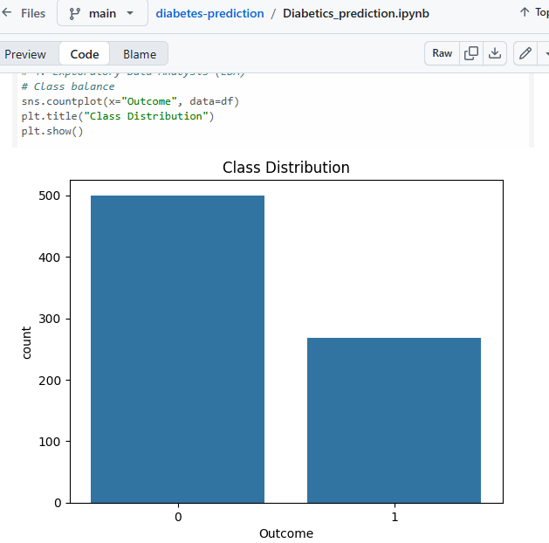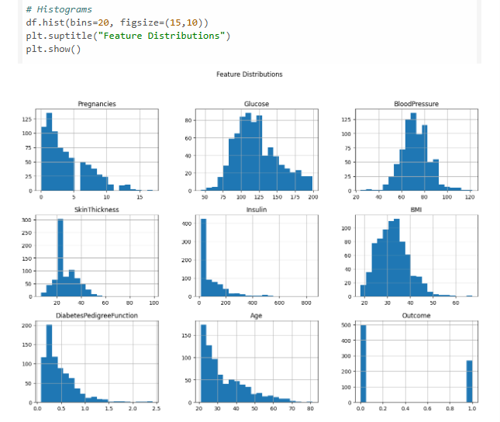
4

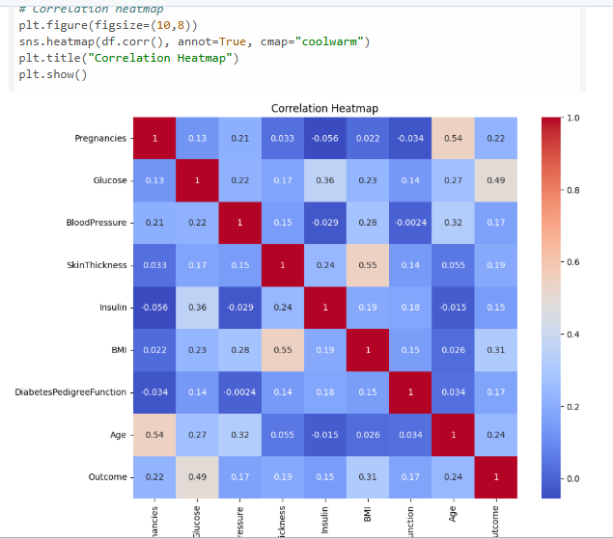

5. Modeling
Three classification models were applied:
- Random Forest Classifier – Achieved ~80% accuracy.
- Logistic Regression – Provided interpretable coefficients.
- XGBoost – Enhanced performance with boosting techniques
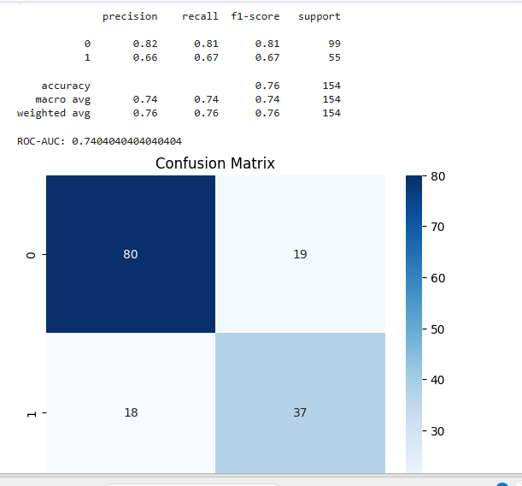
6. Evaluation
Performance metrics included:
- Accuracy: ~80% (Random Forest).
- Precision & Recall: Balanced across classes.
- ROC-AUC: Demonstrated strong predictive ability.
- Confusion Matrix: Showed correct vs incorrect predictions. 6

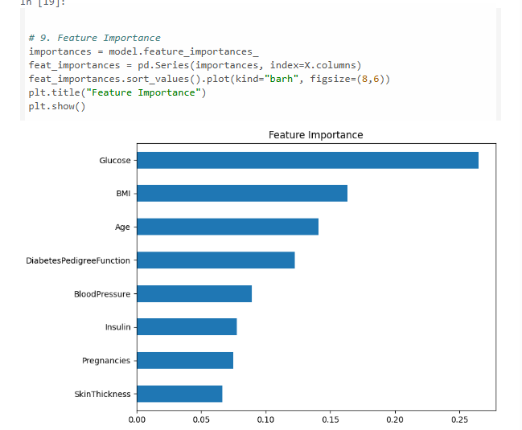
7. Feature Importance
Analysis revealed that the most influential predictors of diabetes are:
- Glucose levels
- BMI (Body Mass Index)
- Age
These features consistently ranked highest across models.
8. Ethical Considerations
While this project demonstrates the potential of data analytics in healthcare, it is for educational and portfolio purposes only. Real-world applications must ensure:
- Patient privacy
- Fairness in predictions
- Transparency in model decisions
9. Conclusion
This project demonstrates the power of data analytics in healthcare prediction. By combining preprocessing, visualization, and machine learning, meaningful insights into diabetes risk factors were obtained.

7

